HR Database

Q1. SELECT first_name as 'First Name', Last_Name as 'Last Name' FROM hr.employees;

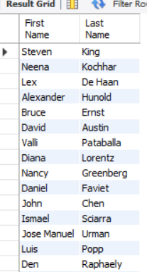

Q2. select distinct(department_id) from hr.employees;

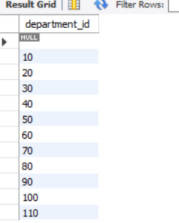

Q3. select * from hr.employees order by first_name desc;

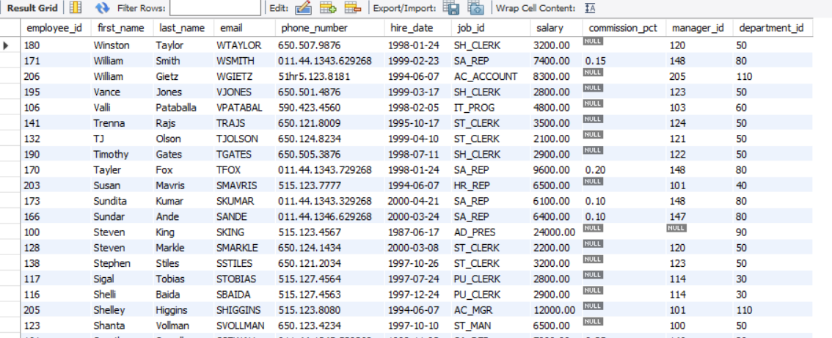

Q4. Select first_name, Last_name, Salary, Salary*.15 ‘PF’ from hr.employees;

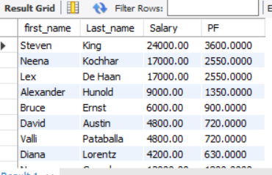

Q5. SELECT employee_id,first_name,last_name,salary FROM hr.employees

ORDER BY SALARY ;

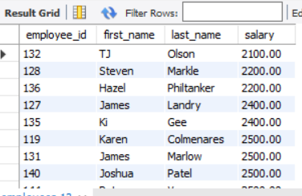

Q6. select sum(salary) from hr.employees;

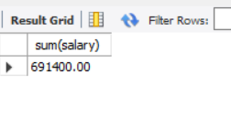

Q7. select max(salary), Min(salary) from hr.employees;

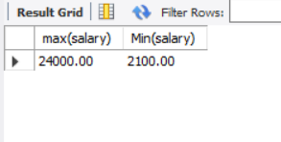

Q8. select Avg(salary), count(*) as No_of_Employees from hr.employees;

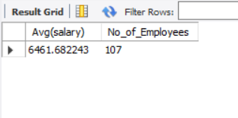

Q9. select count(*) from hr.employees;

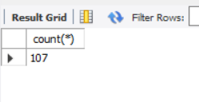

Q10. Select Count(distinct(job_id)) from hr.employees;

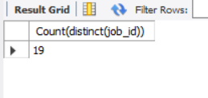

Q11. select upper(first_name) from hr.employees;

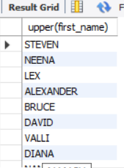

Q12. select substring(first_name,1,3) from hr.employees;

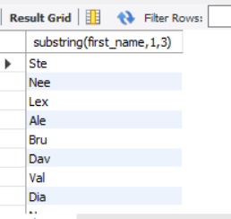

Q13. Select trim(first_name) from hr.employees;

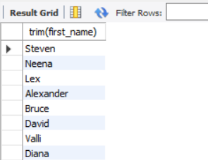

Q14. select length(First_name), length(last_name) from hr.employees;

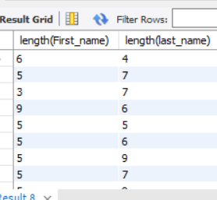

Q15. select First_name from hr.employees where First_name regexp ‘(0-9)’;

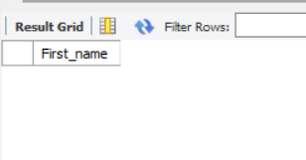

Q16. Select first_name, last_name, Salary from employees

where salary not between 10000 and 15000;

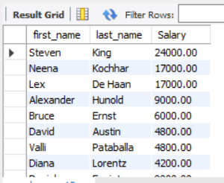

Q17. select first_name, last_name,Department_id from hr.employees

where department_id in (30,100);

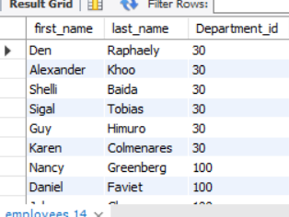

Q18. Select first_name, last_name, Salary from employees

where salary not between 10000 and 15000 and department_id in (30,100);

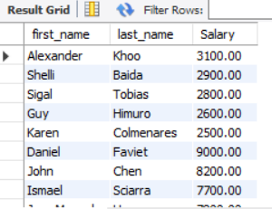

Q19. select first_name, last_name, hire_date from hr.employees

where year(hire_date) = 1987;

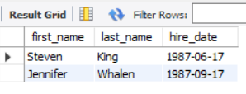

Q20. select first_name from hr.employees

where first_name like ('%b%') and First_name like ('%C%');

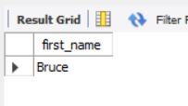

Q21. select last_name, job_id, salary from hr.employees

where job_id = 'IT_PROG' or job_id = 'SH_CLERK' and salary not in (4500,10000,15000);

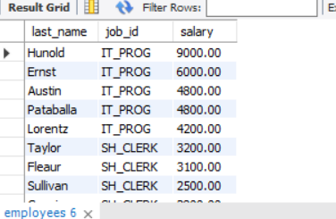

Q22. select last_name from employees where last_name like '______';

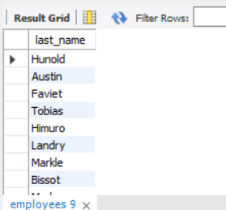

Q23. select last_name from employees where last_name like '__E%';

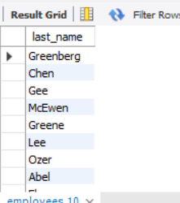

Q24. Select job_id, group_concat(employee_id, ' ') 'employee_id' from employees group by job_id;

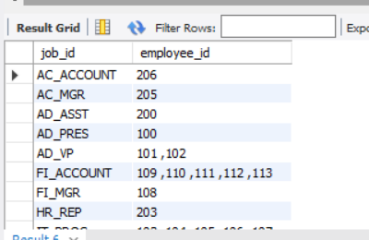

Q25. update employees set phone_number = replace(Phone_number, '124', '999');

select phone_number from hr.employees where phone_number LIKE '%999%';

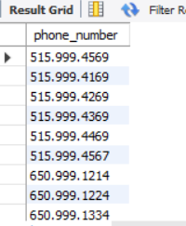

Q26. SELECT * FROM hr.employees where length(first_name) >=8;

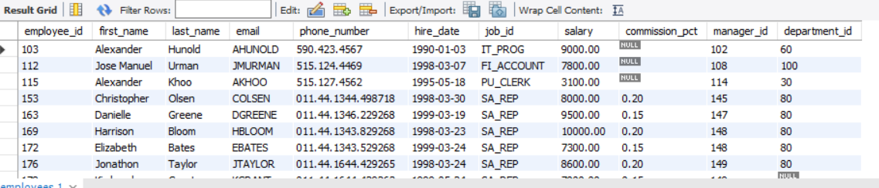

Q27. update employees Set email = concat(email, '@Example.com');

Select email from employees;

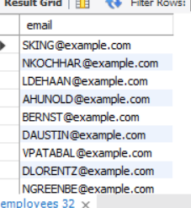

Q28. Select right(phone_number,4) from hr.employees;

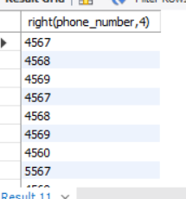

Q29. SELECT SUBSTRING_INDEX(REPLACE(REPLACE(REPLACE(street_address,',',' '),')',' '),'(',' '),' ',-1)

AS 'Last--word-of-street_address'

FROM locations;

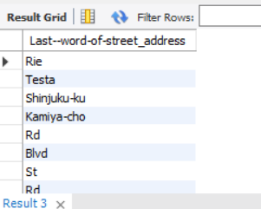

Q30. Select * from locations

where length(street_address) <= (select min(length(street_address)) from locations);

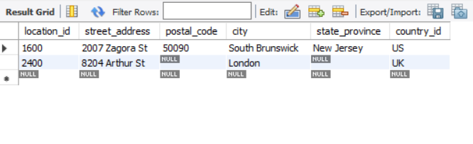

Q31. select substr(job_title, 1, instr(Job_title, ' ')) from jobs;

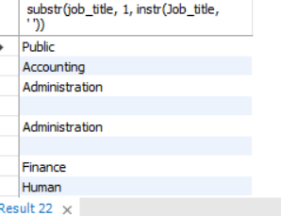

Q32. select length(First_name) from hr.employees

where last_name like '%__c%';

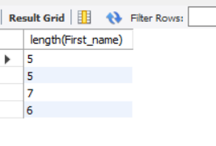

Q33. select first_name, Length(first_name) from hr.employees

where first_name like 'A%' or First_name like 'J%' or first_name like 'M%'

order by first_name;

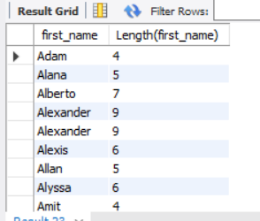

Q34. Select First_name, Lpad(salary, 10, $) Salary from employees;

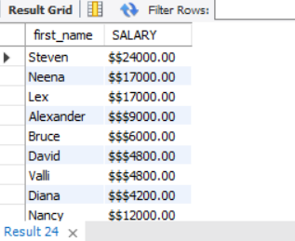

Q35. select left(first_name,8), repeat('$', floor(Salary/1000))

'Salary$', salary from hr.employees;

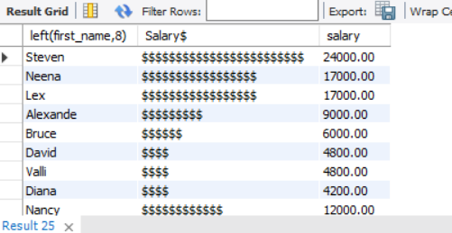

Q36. Select first_name, employee_id, last_name, hire_date from hr.employees

where day(hire_date) = 7 or month(hire_date) = 7;

